Instructions for Loan Pack Automator:

Created by Connor Buchalter – [conncon@yahoo.co.uk](mailto:conncon@yahoo.co.uk) for further enquiries

Contents

Introduction 1

Usage 1

Creating New Documents 8

Adding New Loan Pack 14

Dealing with Errors 19

Document Cannot Be Found 20

Field ‘x’ in loan pack translation table is blank/filler 22

‘Field’ could not be found in loan pack translation table 23

The ‘loan pack’ sheet does not have a matching Templates Folder 24

The file ‘x’ must have the extension .docx 24

Super Special Beta Feature that is definitely not a prank™ 26

# Introduction

This software is designed with the intention to be a flexible tool for creating and automating templates. It was intentionally designed to be very generalised to enable you to computerise more documents than just loan packs. Whilst everything in this document is referred to in the context of loan packs – please note that this is just for convenience of explanation.

# Usage

1. If you have saved the Auto Loan Pack folder in a different location, navigate there, and skip to step 4 or go to the K: Drive
2. Open the folder entitled “Amal”
3. Open the folder entitled “Auto Loan Pack”
4. Open the excel spreadsheet entitled “automation” – **DO NOT OPEN ~$automation**
5. If you are greeted with the following screen, skip to step 7:

Appearance of Spreadsheet when opened

1. If you do not see the above screen, click the word **Master**, in the bottom left corner
2. Now that you are on the Master sheet, click on cell C2, containing the word “Octopus” in the image above
3. This will create a dropdown menu, allowing you to choose between all the different groups of documents (e.g., all the Octopus documents, all the Romaco Documents, etc)

Dropdown for groups of documents

1. Once you have chosen the selection of documents you wish to use, the table with the heading “File Wanted” will update. This is pictured below:

File Wanted Table for Romaco Documents

1. The above table contains all the documents currently set up to work for this loan pack.
2. Clicking on a cell in the column with the heading “Yes/No” creates a dropdown, allowing you to choose whether you want the computer to generate this file or not

1. Once you have selected all the documents you wish to generate, click the “Generate Input Fields” button

1. Clicking this will cause the status to change to “In Progress”, be patient and wait until it reads “Complete”
2. This will bring up a list of all the inputs needed to complete these files, pictured below:

1. Once you have filled in all the fields in the Values column as shown below, click the “Create Files” button - **IF YOU LEAVE A FIELD BLANK IT WILL APPEAR AS THE WORD “NONE” IN THE CREATED FILE**

Create Files Button

1. This will change the Status indicator to “In Progress” and may take a couple of seconds
2. If no error messages appear, skip this step, otherwise refer to the Dealing with Errors section of this document
3. When the status indicator reads “Complete”, the program is done and you can retrieve your files from the “Output” folder
4. Any documents you create will overwrite anything in the “Output” folder that shares the same name, e.g. a new Roma Debenture will overwrite an old Roma Debenture but not an old Solicitors Certificate

1. You can now make edits to your generated documents – be sure to remove the highlighting, you can do this quickly by pressing Ctrl + A and then the highlight button set to no colour
2. Once you have finished editing, select all the documents and drag them into Seneca
3. After this, it is best practice to delete the documents in the “Output” folder to keep it tidy
4. Once you are done, you can click the “Reset” Button to return the spreadsheet to its starting appearance.

Reset Button

Spreadsheet is reset

# Creating New Documents

In this section, I will walk you through adding new documents and document groups to this tool. We will do this by demonstrating how to automate a Cheque Requisitions Form.

1. If you are not creating a template for an existing selection of documents (e.g. Octopus, Roma), skip to the Adding a New Loan Pack Section and then return, otherwise continue
2. If you already have a template document correctly formatted for this program, skip to step 12, otherwise continue
3. Find the document you wish to turn into a template for this software on Seneca or another location

1. Open the fileGraphical user interface, application, Word

   Description automatically generated
2. Add input fields in the relevant places – the fields must obey the following rules
   1. Spaces, numbers and special characters (&,*,?) cannot be used
   2. The input fields must be surrounded by two curly brackets on either side {{ }}
   3. There must be a space between the text of the field and the brackets
   4. You can highlight all the input fields if you want someone to have to check through them
   5. The input fields keep whatever formatting you give them – bold, font size, underlined
   6. Example input field: {{ this_is_an_EXAMPLE }}
3. When you are done, it should look something like this:

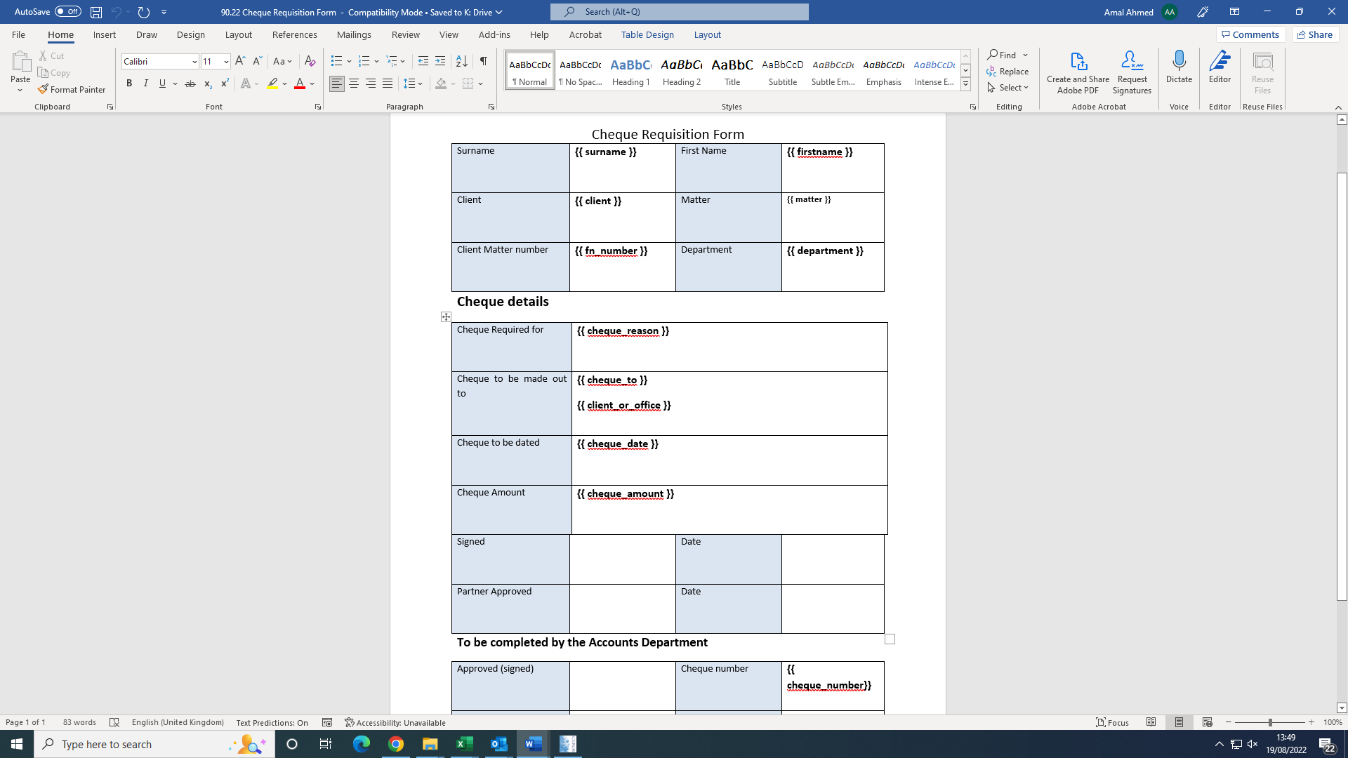

Finished Template

1. After you have created your template, you need to save it in the correct folder
2. Click File:

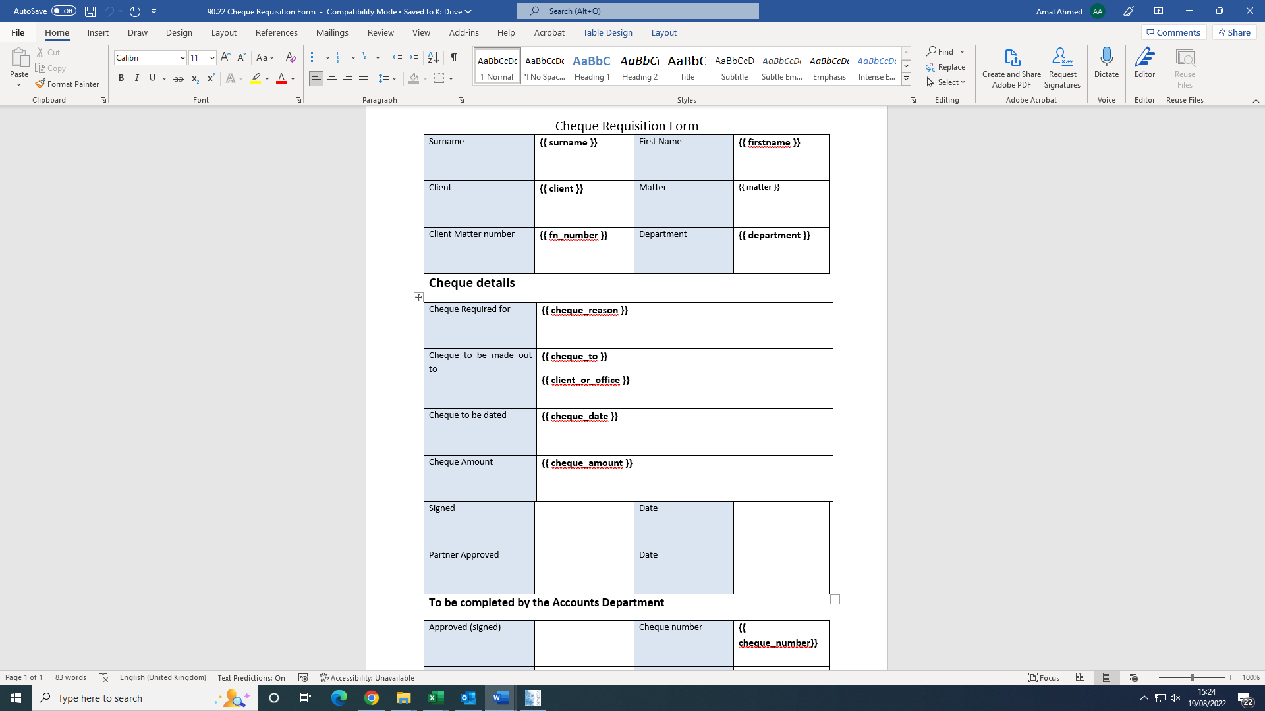

1. Click Save As, then click the box below the file name and make sure the file is set to Word Document (*.docx), finally click the file path

1. Navigate to the Auto Loan Pack folder, then to the Templates folder, then to the folder that shares a name with the document group you are trying to create (Roma, Blue_Square)

1. Open that folder and click save
2. Now return to the automation spreadsheet and click on the tab for your document group

1. This will open a screen that looks like this:

1. On the left table, entitled “FileNames”, you are going to write or copy/paste the name of your template file verbatim, like so:

1. Then in the column with heading “MachinePlaceHolder”, you are going to write each different input field for your file, excluding the curly brackets – if it already exists in the table you don’t need to do this:

1. Finally, you need to give each input field a translation that will be displayed in the “Master” spreadsheet, these do not need to follow any special rules:

1. Make sure anything left blank in either of the tables is changed to the word “filler”
2. Now you are finished and can return to the “Master” spreadsheet and use this new document and document group

# Adding New Loan Pack

To add a new Loan Pack, right click on the “Template” sheet in the bottom right corner.

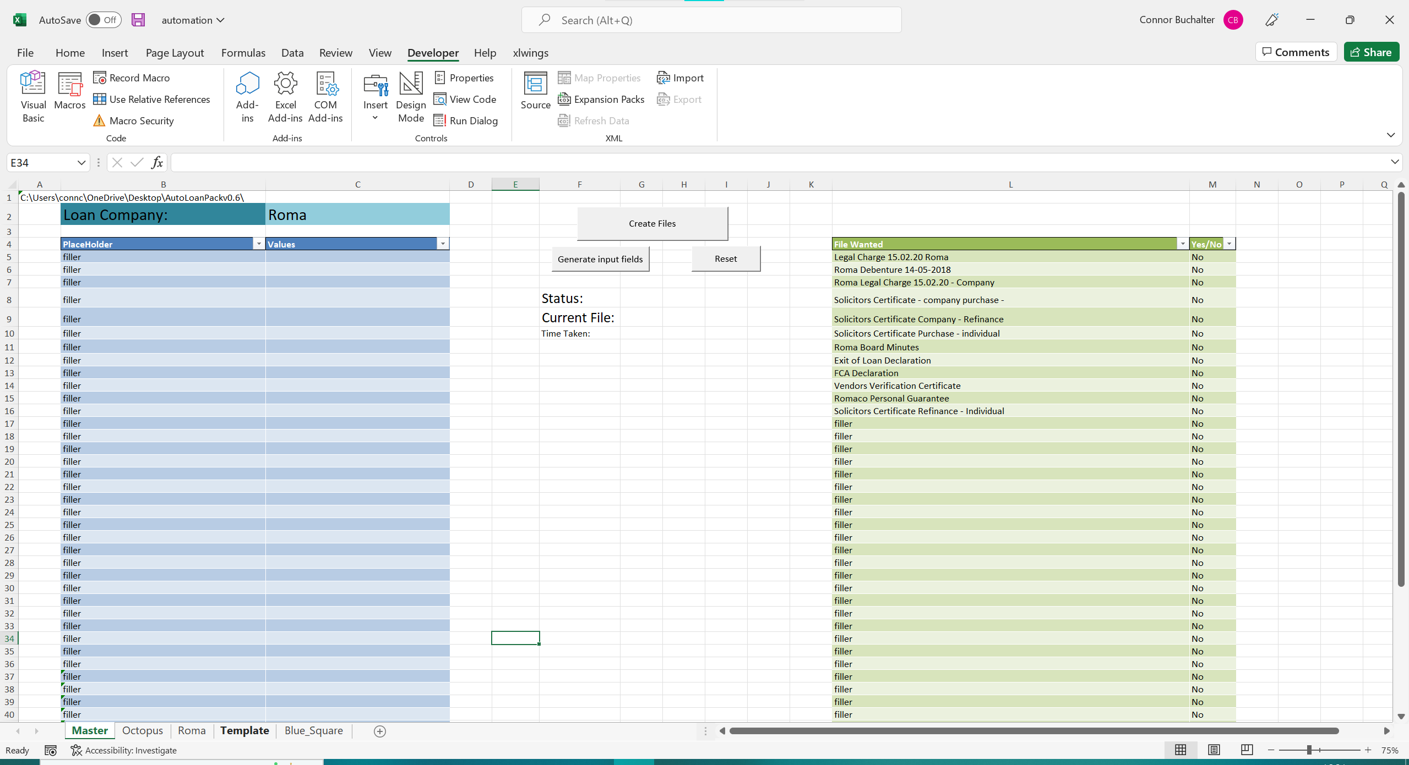

Then click move or copy.

On the “Move or Copy” form click “Template” and then tick the box labelled “Create a copy”.

Click the “OK” button. A new sheet will then be created, likely with the name “Template (2). Right click its name in the bottom right corner and select “Rename”. From there, change its name to the name of the Loan Pack and press Enter. **IMPORTANT: DO NOT HAVE SPACES IN THE NAME (UNDERSCORES CAN BE A GOOD SUBSTITUTE) AND DO NOT INCLUDE SPECIAL CHARACTERS – E.G., “&”**

A good name would be “Bath_and_West”.

Then, in the “Master” sheet, click on cell C2, then select the Data Heading in the Excel Ribbon. After that, select data validation.

That will bring up this table:

To add your loan pack, click on the Source textbox and then write a comma and the name of your loan pack, matching what you wrote during the “Rename” section exactly. Then click the “OK” button.

The final step is to open the “Templates” folder and right click, selecting New -> Folder. Once this folder is created name it, so its name matches exactly what you entered in the “Rename” and “Data Validation” steps.

Now you are done and can fill this folder with documents.

# Dealing with Errors

In the event of a mistake the program will stop its execution and provide you with an error message. These will appear as pop up, as seen below:

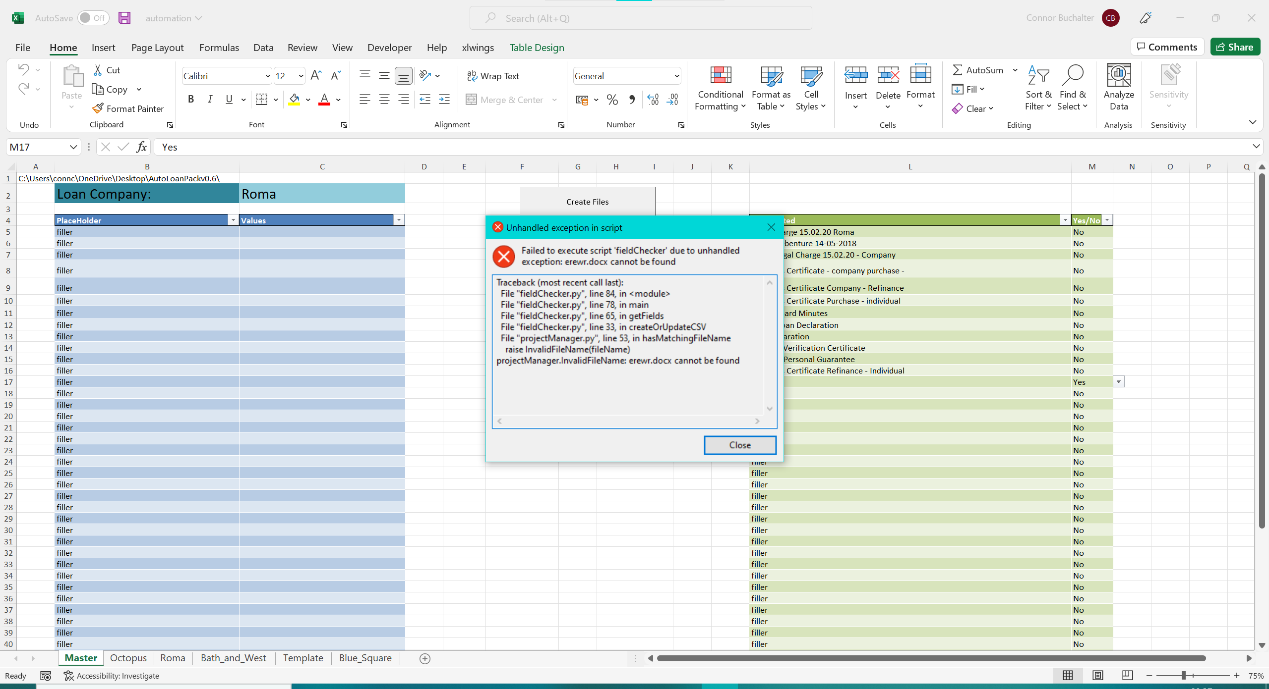

Although they do contain information regarding the error, they are difficult to read, so I recommend pressing the “Close” button. Another popup will appear, press the “OK” button. Finally, you will be left with red text in the 11th row of the “Master” sheet, describing the error.

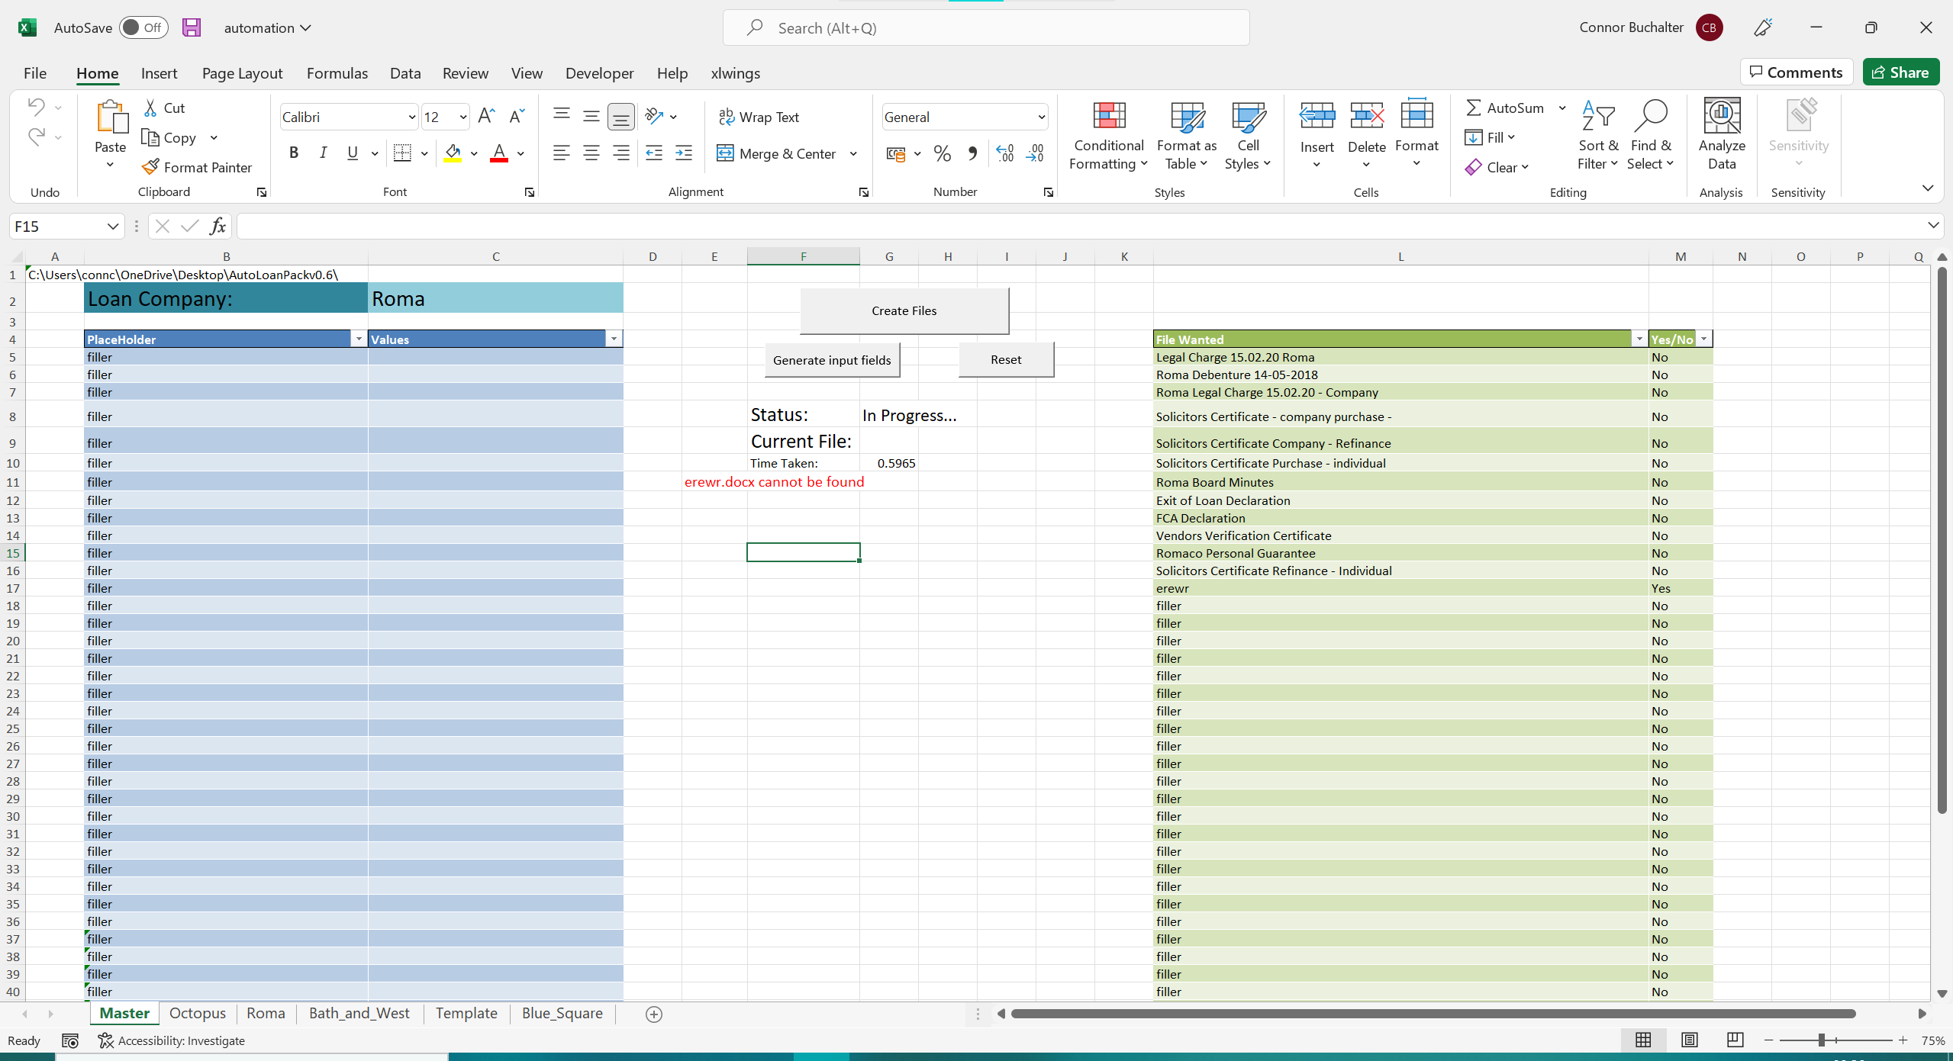

There are a few different types of error:

## Document Cannot Be Found



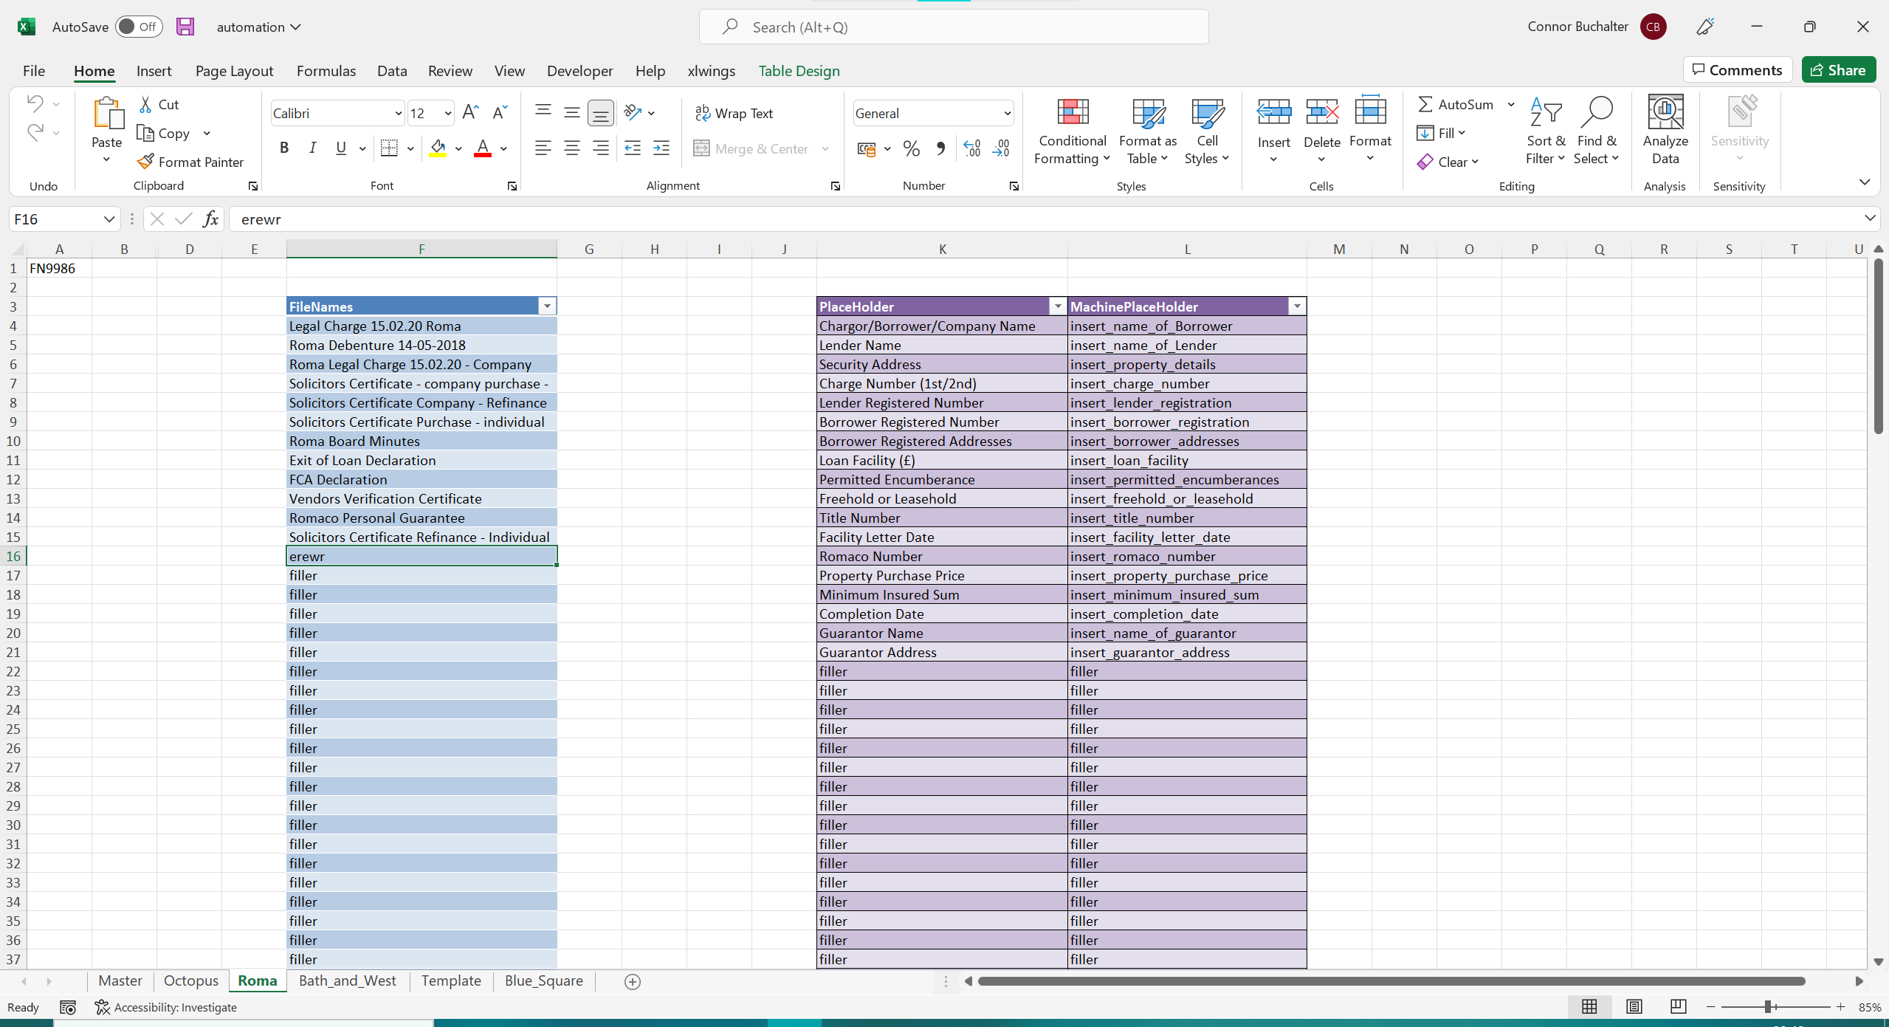

This tells you that a selected document cannot be located within the Templates folder

Troubleshooting Steps:

1. Go to the Loan Pack Sheet – e.g. Roma Sheet and make sure the listed document isn’t written accidentally in the “FileNames” Table (erewr.docx is clearly not a document, probably a typo)
2. Make sure the document name is spelt correctly in the “FileNames” Table and matches the name of the document in the Loan Pack Templates Folder.
3. Make sure the name of the document in the “FileNames” Table has no extension (.docx)
4. Go to the Templates Folder and then to the folder for your loan pack – Make sure the file is in the correct place

## Field ‘x’ in loan pack translation table is blank/filler

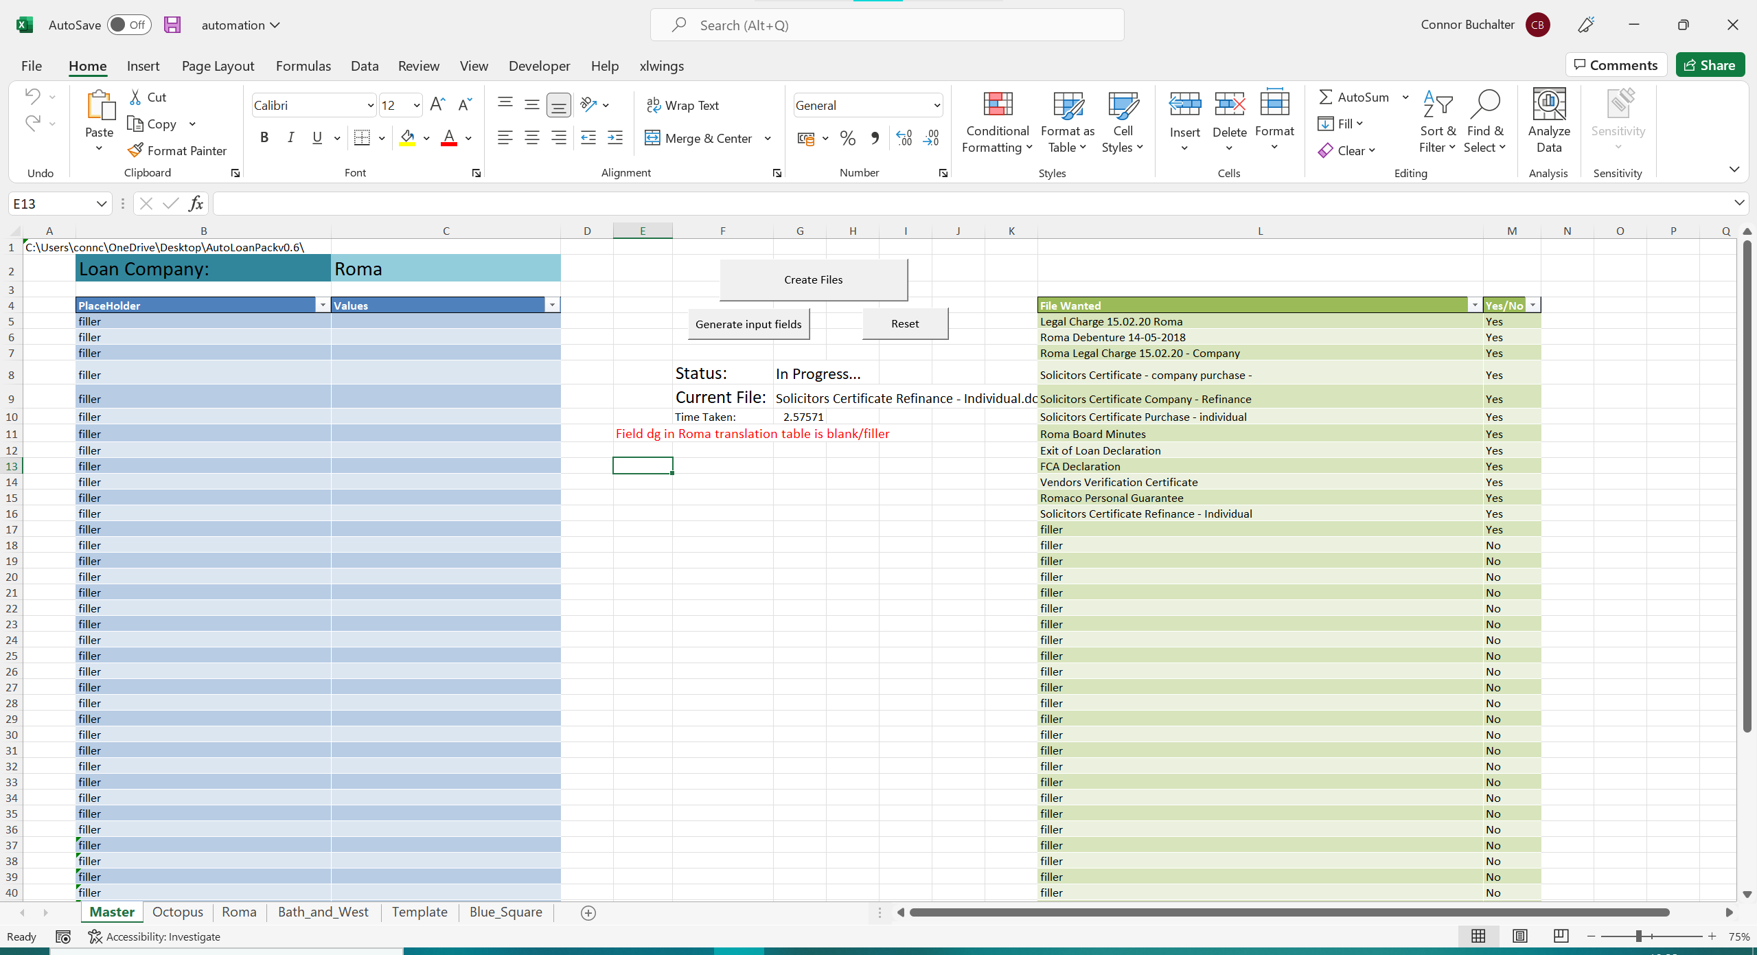

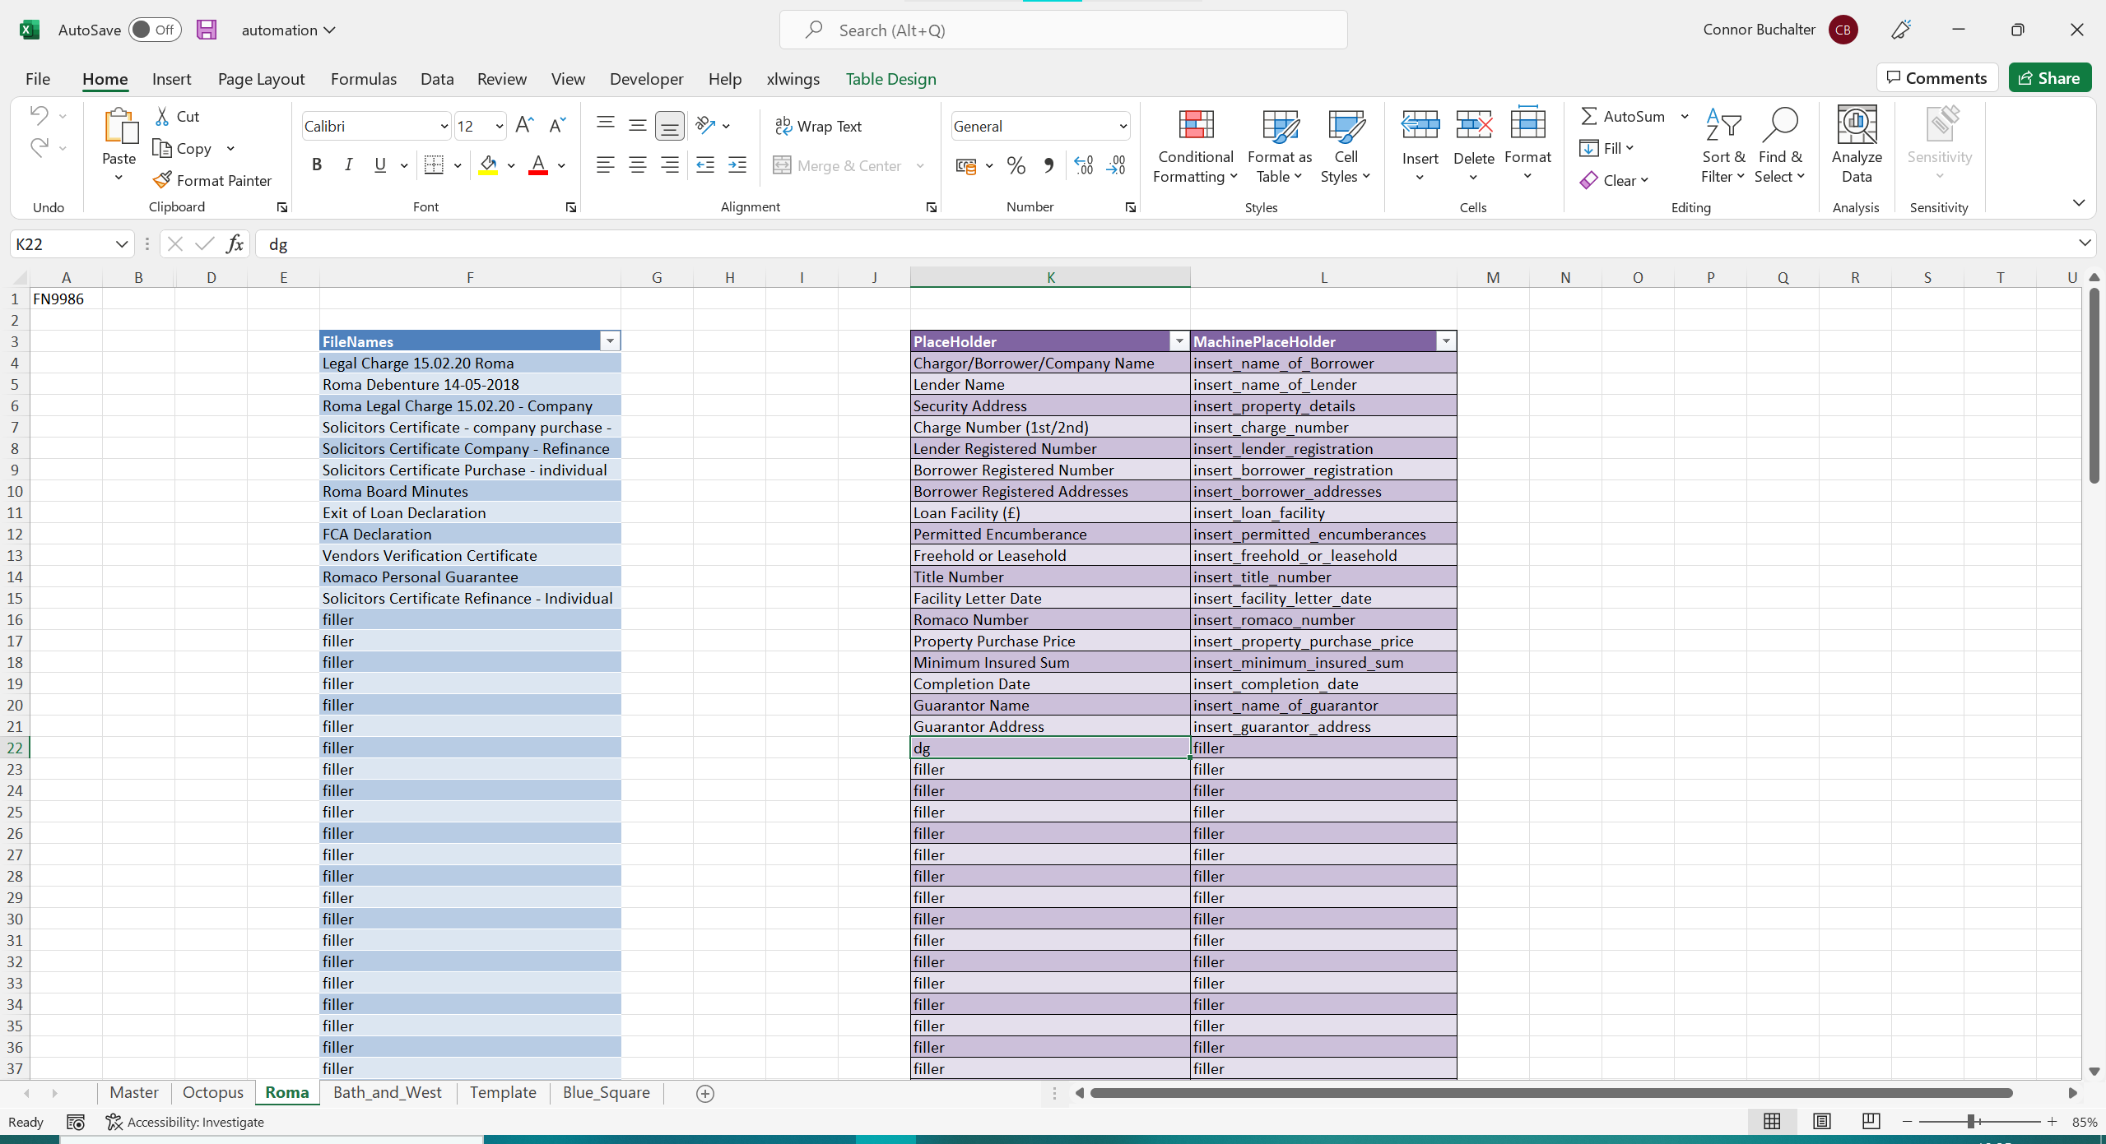

This error means that there is a field in the PlaceHolder Column of the selected Loan Pack’s translation table that does not have a translation for the computer to read.

Troubleshooting Steps:

1. Remove any accidentally typed fields, replacing it with “filler”
2. Provide a translation for the field

## ‘Field’ could not be found in loan pack translation table

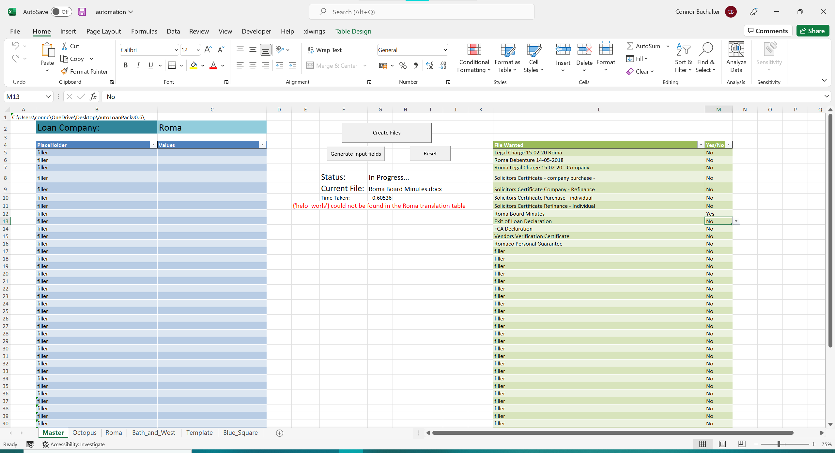

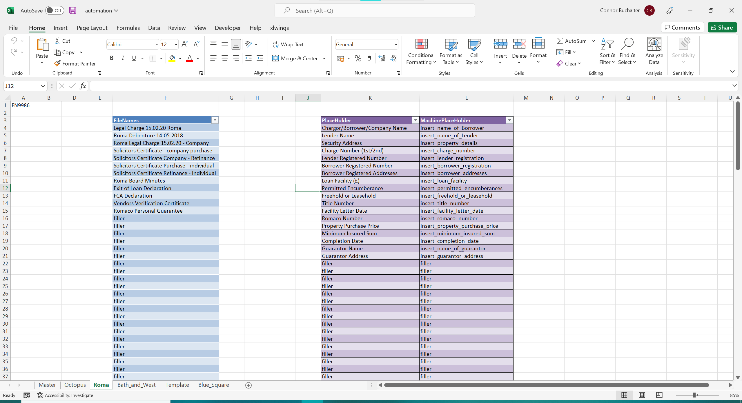

This error means that there is a field in the files that is not listed in the translation table for the specified loan pack.

Troubleshooting Steps:

1. If the listed field is supposed to exist, add it to the translation table
2. If the listed field is not supposed to exist, check through your “Wanted Files” to see where that field appears and delete it
3. If those solutions fail, go to the Templates folder, you will see a csv/excel file with the same name as your loan pack – delete it

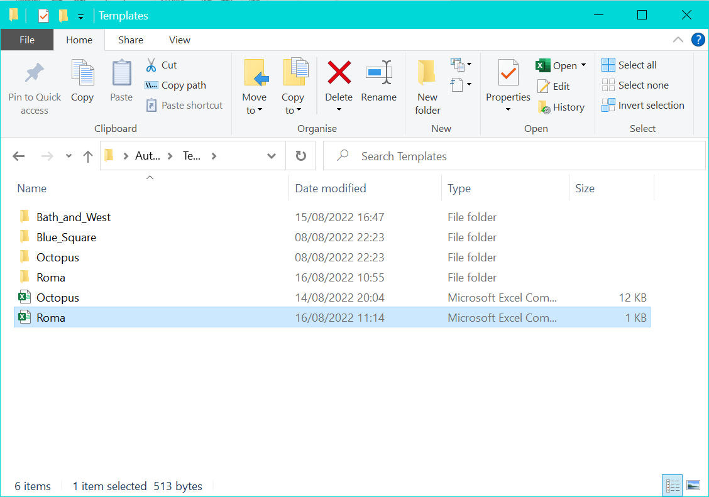

## The ‘loan pack’ sheet does not have a matching Templates Folder

This error means that the program cannot find a subfolder in the “Templates” folder that shares the name of the Loan Pack Sheet in the excel spreadsheet.

Troubleshooting Steps:

1. Check that you have created a subfolder within Templates with the same name as your loan pack
2. Check that the names of the Loan Pack Spreadsheet, the dropdown in Cell C2 and the loan pack template folder match
3. Check the above names do not contain special characters (e.g. !,?,&,”), some special characters are fine, like underscores, but it is best to avoid them all together
4. Check the above names do not contain spaces – if they do change them

## The file ‘x’ must have the extension .docx

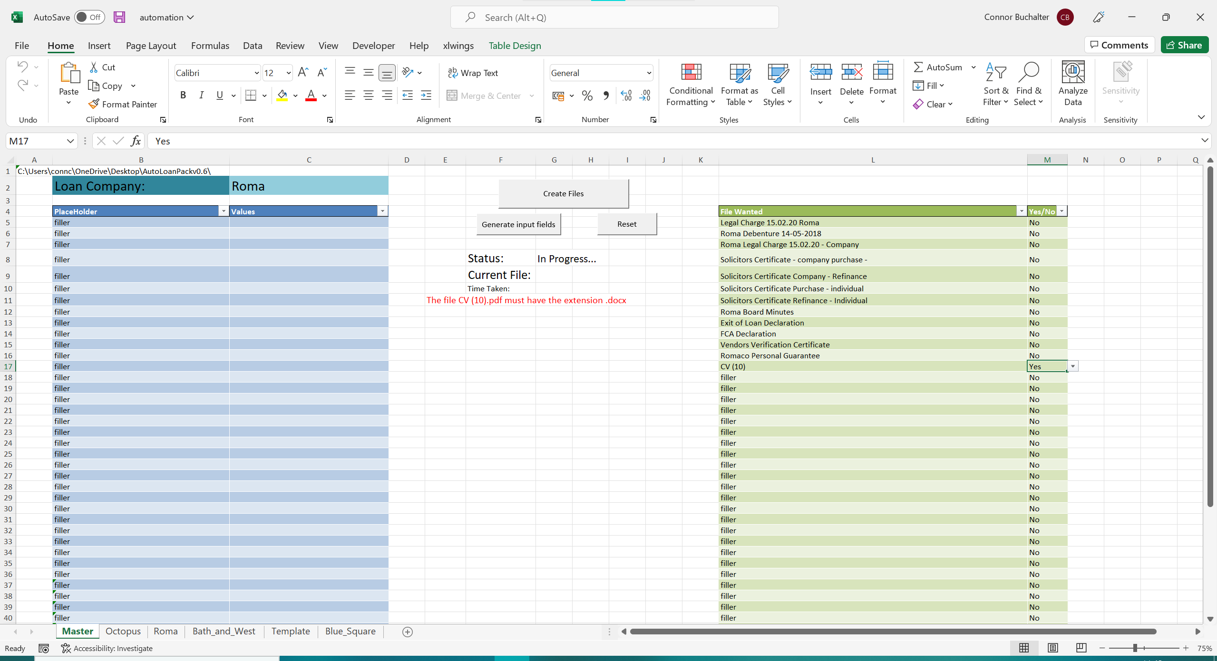

Here, the issue is that the program only accepts .docx documents, while we have given it a pdf.

Troubleshooting Steps:

1. See if you can replace the file with an existing .docx version
2. If the file is a pdf, you can convert it to a word document by uploading it to [this](https://www.adobe.com/uk/acrobat/pdf-to-word.html) website, please note converting .pdf to .docx can produce errors in the file
3. If the file is a .doc file or for an older version of word, it can be converted to a .docx through the following method:
   1. Open the .doc document
   2. Click the file tab in the ribbon in the top left
   3. Click Save As
   4. In the Save As Type Menu, select “Word document (.docx)”

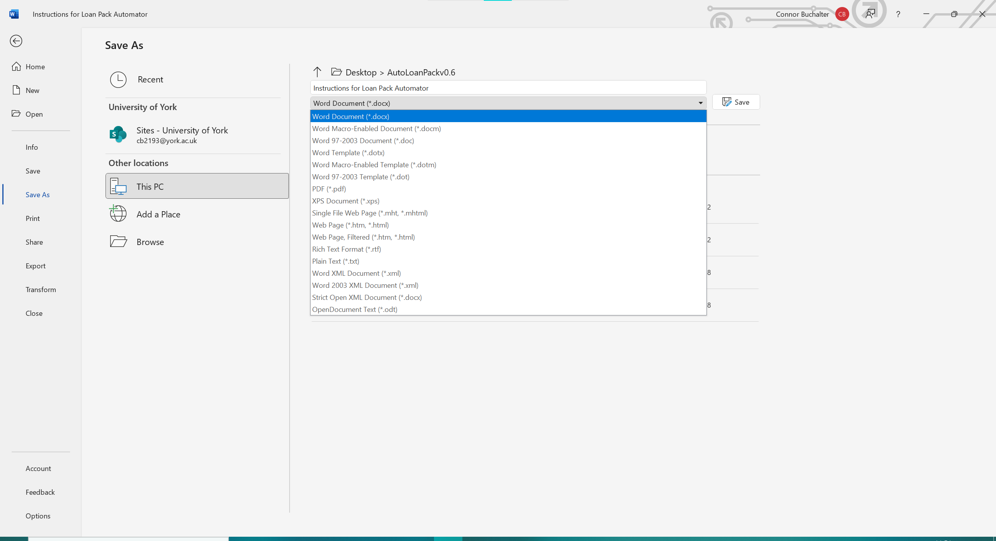

# Super Special Beta Feature that is definitely not a prank™

To add the Super Special Beta Feature that is definitely not a prank™, right click on the “Create Files” Button.

Click “Assign Macro” and it will bring up the following table.

Double click on the option entitled “Beta Feature” and enjoy!

To return to regular functionality repeat the same steps as before but double click the option that reads “CallExe” instead of “Beta Feature”.